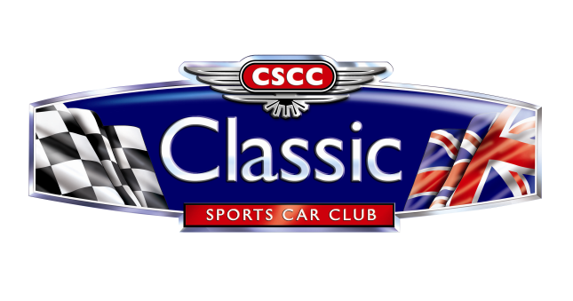

2020 ADDITIONAL TROPHY ORDER FORM
Name
Circuit | Thruxton – 25/26 July  Snetterton – 15/16 August  Donington Park – 26/27 September  Castle Combe – 24 October  Mallory Park – 1 November
Position | Race Winner 1st in Class  2nd in Class 3rd in Class

Trophy prices are as follows (no VAT):
Race Winner/1st in Class - £20
2nd in Class - £17
3rd in Class £15
Please send completed forms to: info@classicsportscarclub.co.uk
We are unable to post awards to you. We will bring them along to the next race meeting you have entered.

Please make Cheques payable to: Classic Sports Car Club Ltd
Or please debit my Credit/Debit card: (We regret we are unable to accept AMEX)
Card Number:

Expiry Date: Security Code:
For your security, if returning this form by email, please phone through your card details to us on 01225 810655

