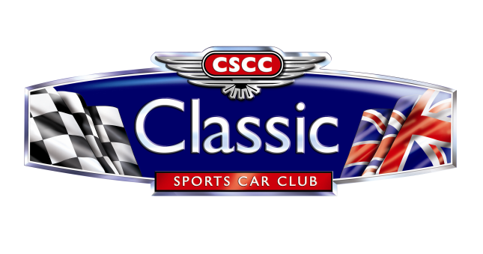

2021 ADDITIONAL TROPHY ORDER FORM
Name
Circuit |  |  | Position
Oulton Park – 10th April  Thruxton – 1st/2nd May  Brands Hatch GP – 22nd May (Tin Tops)  Donington Park – 29th/30th May  Cadwell Park – 12th/13th June  Knockhill – 3rd/4th July  Snetterton 300 – 14th/15th August  Brands Hatch – 28th/29th August  Anglesey – 25th/26th September  Silverstone GP – 24th October |  |  | Race Winner  1st in Class  2nd in Class  3rd in Class
Trophy prices are as follows (no VAT):
Race Winner/1st in Class - £20
2nd in Class - £17
3rd in Class £15

Please send completed forms to: info@classicsportscarclub.co.uk
We are unable to post awards to you. We will bring them along to the next race meeting you have entered.
Please make Cheques payable to: Classic Sports Car Club Ltd
Or please debit my Credit/Debit card: (We regret we are unable to accept AMEX)
Card Number:

Expiry Date: Security Code:
For your security, if returning this form by email, please phone through your card details to us on 01225 810655

